Alpha - Version
SRS DOCUMENT
(Software Requirements Specification)

Project Manager: Bhekabona Mbhele
Project: Batch Mixer Report System
Plant: High Chrome Ball Plant
Version: 1.0.0.0
Prepared by: Tsundzukani Nkuna
From Date: 2025/ 06/ 26 To Date: 2025/ 06/ 27
Project Objectives: The objective of the project is to provide easy and convenient access to the sand batch records across the three casting sections at High Chrome Ball Plant.
Contents
INTRODUCTION 3
1.1. Scope 3
1.2. Intended Audience 4
OVERALL DESCRIPTION 5
2.1 Product Perspective 5
2.2 Product Features 5
2.3 User Characteristics 6
2.4 Constraints 6
Non-Functional Requirements 6
3.1 Performance Requirements 6
3.2 Safety Requirements 6
3.3 Security Requirements 6
3.4 Usability Requirements 6
SYSTEM FEATURES 7
4.1 Select by Production Line (Combo Box) 7
4.1.1 Description and Priority 7
4.1.2 Stimulus/Response Sequences 7
4.1.3 Functional Requirements 7
4.2 Select by Date and Time 8
4.2.1 Description and Priority 8
4.2.2 Stimulus/Response Sequences 8
4.2.3 Functional Requirements 8
4.3 Export to Excel 9
4.3.1 Description and Priority 9
4.3.2 Stimulus/Response Sequences 9
4.4.3 Functional Requirements 9
USE CASES 10
5.1 Use Cases Figure 10
USE CASES SPECIFICATION 11
6.1 UC.01 11
6.2 UC-02 12
6.3 UC-03 13
USER ACTIVITY DIAGRAM 14
7.1 User Activity Diagram Figure 14
USER ACTIVITY DIAGRAM AND USER BREAKDOWN STORIES 15
8.1 UAD Production Line 1 15
8.1 Operator View Production Line 1 Report 15
8.2 UAD Production Line 2 16
8.2 Operator View Production Line 2 Report 16
8.3 UAD Production Line 3 17
8.3 Operator View Production Line 3 Report 17
DATABASE ERDs 18
9.1 Erd Figure 18
CONCLUSION 18

INTRODUCTION
This Requirements Gathering Template defines the foundational elements of the Batch Mixer Report System – Alpha Version, intended for implementation at the High Chrome Ball Plant. This system marks a critical advancement in the plant’s digital transformation strategy, with a focus on enhancing the traceability, and accessibility of sand batching operations data.
Under the guidance of Project Manager Bhekabona Mbhele and technical ownership by Tsundzukani Nkuna, the initiative aligns with the broader operational objective of enabling real-time monitoring, quality assurance, and production traceability across Lines 1, 2, and 3. This alpha release outlines the initial requirements that support key process automation, particularly in data acquisition, batch composition analysis, and report generation.

1.1. Scope
The Batch Mixer Report System for the High-Chrome Ball Plant is being developed to automate the collection, storage, and presentation of sand-batch data from Line 1, Line 2, and Line 3. For each sand batch produced on a given day the system will:
- Connect to a HCBP SQL SERVER AUT-ENG\GM_PRODUCTION to retrieve Mixer Sand-Batch results which is automatically stored and saved to the HCBP-SQL-server from the Scada and thereafter warehoused in AUT-ENG database.
- The system stores all batch records processed through the Sand plant Scada, for each casting line.
- The data accuracy, that is recorded through the Sand plant PLC and Scada is dependent on the scale’s standardization.
- Duplicate entries for the same Lines, date, and time must be filtered in the final app report.
- The app has no access limitations and End-users can view and export data only, no edits are made possible to the information presented in the app.
- Managers and Technicians can upload, edit, and annotate results before final validation.
- Engineers have read-only access to the reports accessed in the app.
- The report can be extracted into excel format, for further processing
- Sand-Batch Report records must include both date and time stamps for traceability.
- Entries older than 5 years may be archived but not deleted
- The system must be accessible during standard plant operating hours (24/7), with scheduled downtime communicated 24 hours in advance.
- Automatic backups of all Sand-Batch Report data must occur every 24 hours.
- The system should retrieve and display query results within 3 seconds for normal data ranges.
- The system presents past day batch records, timed as 7H00 to 7H00.

1.2. Intended Audience
This Software Requirements Specification (SRS) document is intended for a diverse group of stakeholders involved in the development, implementation, and utilization of the Batch Mixer Report System within the High Chrome Ball Plant. The primary audiences include:
- End -User / Operator: Can view and Export data only, no edits are made possible to the information presented in the app.
- Managers and Technicians: Can upload, edit and annotate results before final validation.
- Engineers: Have read-only access to the reports accessed in the app.

NON – FUNCTIONAL REQUIREMENTS

2.1 Availability Requirements
- The system must be available at least 99.75% of the time during business hours (24/7 preferred for plants running continuously).
- Database and application services should be backed up with a disaster recovery plan.

2.2 Performance Requirements
- The system must load filtered data queries within 15 seconds.
- The system must support concurrent access by at least 50 users without performance degradation.
- Export functions (XLSX/PDF) must complete within 5 seconds under normal load.

2.3 Safety Requirements
- The system prevents data corruption or loss during unexpected shutdowns through regular automated backups and transaction logging.
- Input validations are implemented to prevent accidental or malicious entry of harmful data.

2.4 Security Requirements
- Data Transmission: All data transmitted between client and server must be secured.
- Access Control: Granular permissions by Instruments (e.g., only Instrumentation can verify/reject Sand-Batch Report).
- Data Protection: Stored data must be protected against unauthorized access, tampering, or deletion.

2.5 Scalability Requirements
- The system should be designed to scale horizontally with minimal configuration changes.
- Support for future data growth, including:
  - More Production Lines (beyond Line 1, Line 2 and Line 3)
  - Additional Sand-Batch Report types or plants

2.6 Usability Requirements
- The interface should be simple, intuitive, and easy to navigate.
- Users should be able to easily view and understand the data displayed.

OVERALL DESCRIPTION

2.1 Product Perspective
- The Batch Mixer Report System is a standalone application that will integrate with the existing Mixer Sand-Batch environment of the High Chrome Ball Plant. It will be designed to support and enhance the Mixer Sand-Batch results process of each Production Line, particularly those recorded under Line 1, Line 2 and Line 3.

2.2 Product Features
• Database Connectivity
- Connects to a HCBP SQL Server database to retrieve Mixer Sand-Batch Results.
Use The Following Credentials
    - Data Source: AUT-ENG\GM_PRODUCTION
    - Initial Catalog: Sand Rands
    - Use ID: sa
    - Password: Grind@1121
- Uses secure connection strings and handles connectivity errors.
• Mixer Sand-Batch Report information Retrieval
- Executes SQL queries to fetch recent Mixer Sand-Batch results from the Production Line Mixer table.
Uses The Following:
    - Connection String
    - Stored Procedures
    - DataTables
- Supports filtering by Date and Time range selection
- Production Line Selection (Drop-down menu)

2.3 User Characteristics
The system will be used by:
- End -User / Operator: Can view and Export data only, no edits are made possible to the information presented in the app.
- Managers and Technicians: Can upload, edit and annotate results before final validation.
- Engineers: Have read-only access to the reports accessed in the app.

2.4 Constraints
- Development Start: 25 June 2025
- Testing Phase: Frequently after Updates
- Go-Live: Frequently after Updates approval
- Team:
  - MIS Technician
- Technology:
  - IIS (Internet Information Services)
  - SQL Server
  - ASP.NET stack

DATABASE ERDs

3.1 Erd Figure
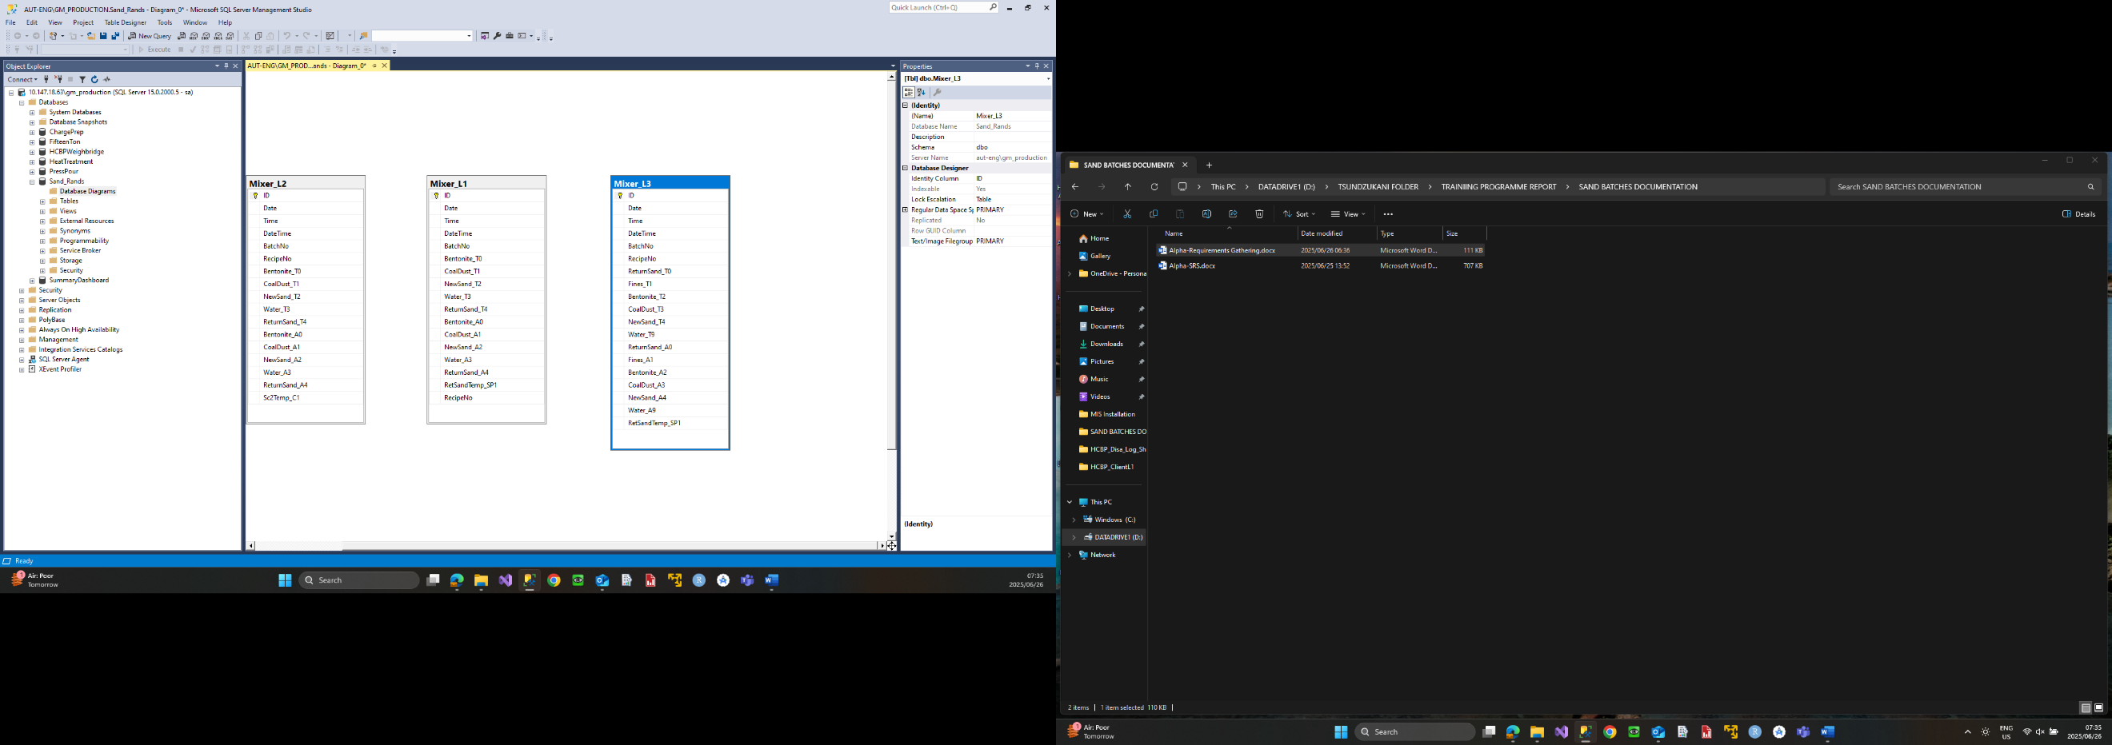

USE CASES

4.1 Use Cases Figure
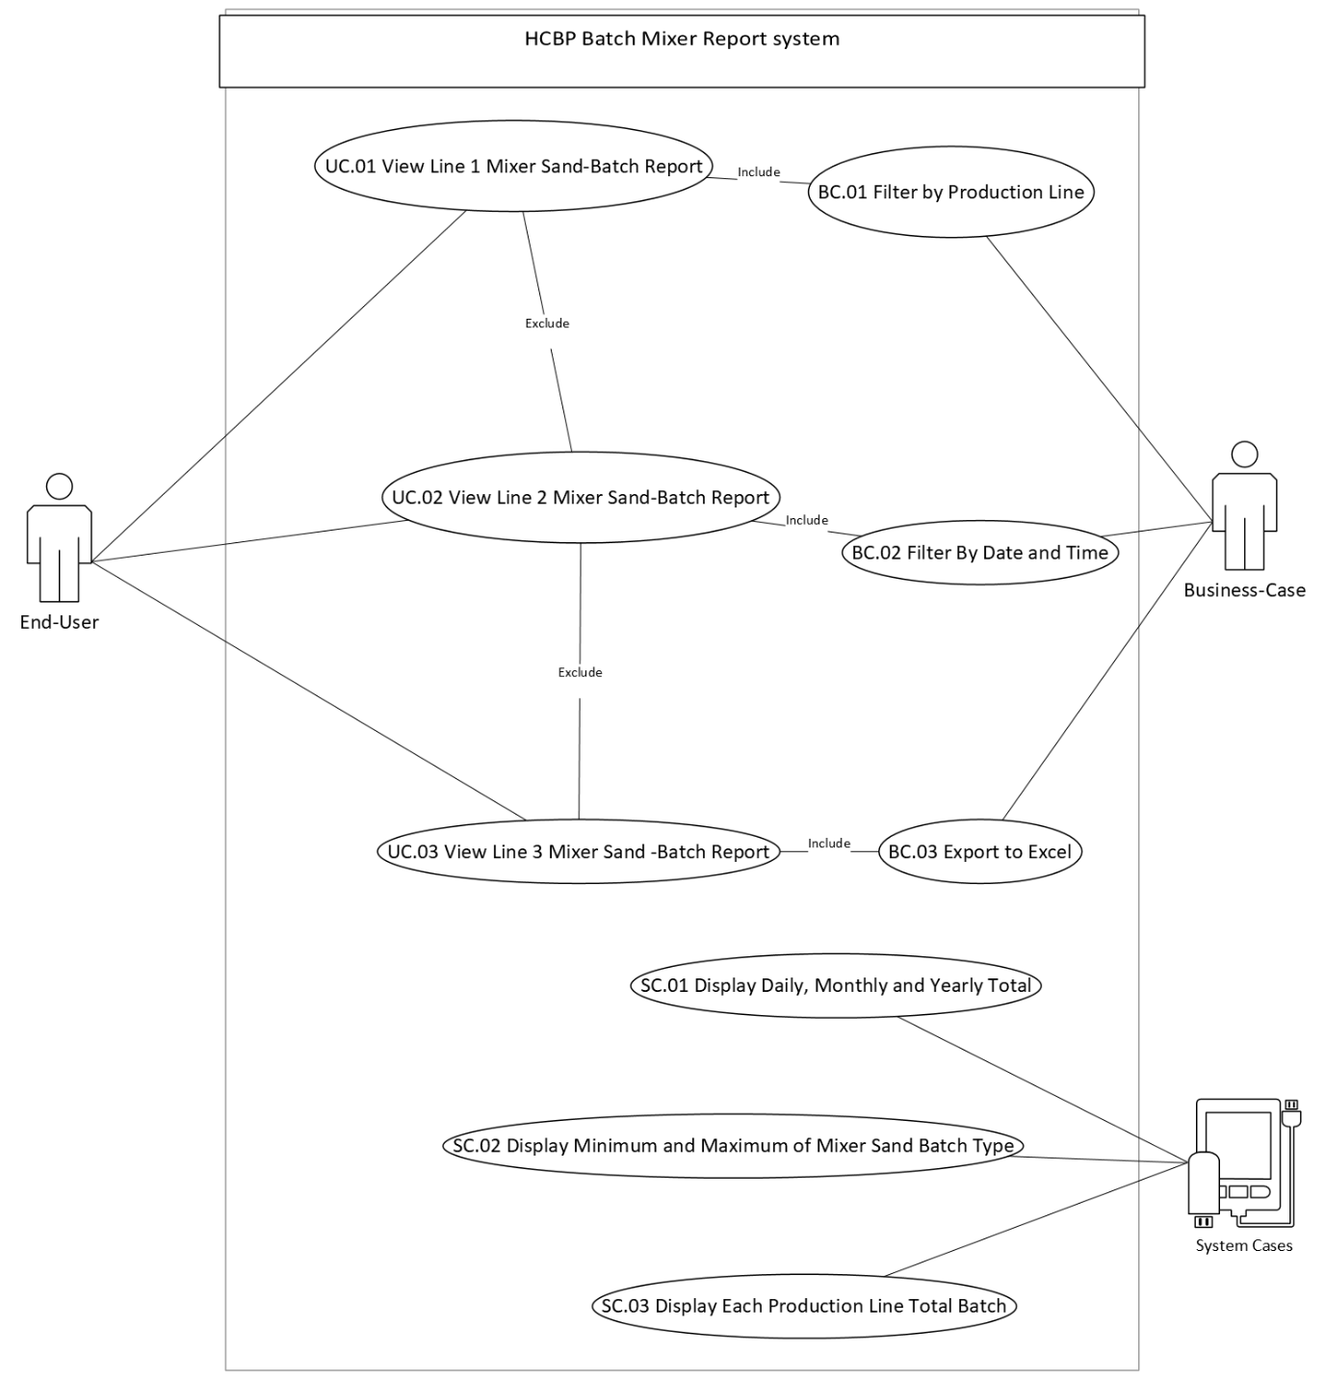

USE CASES SPECIFICATION

5.1 UC.01
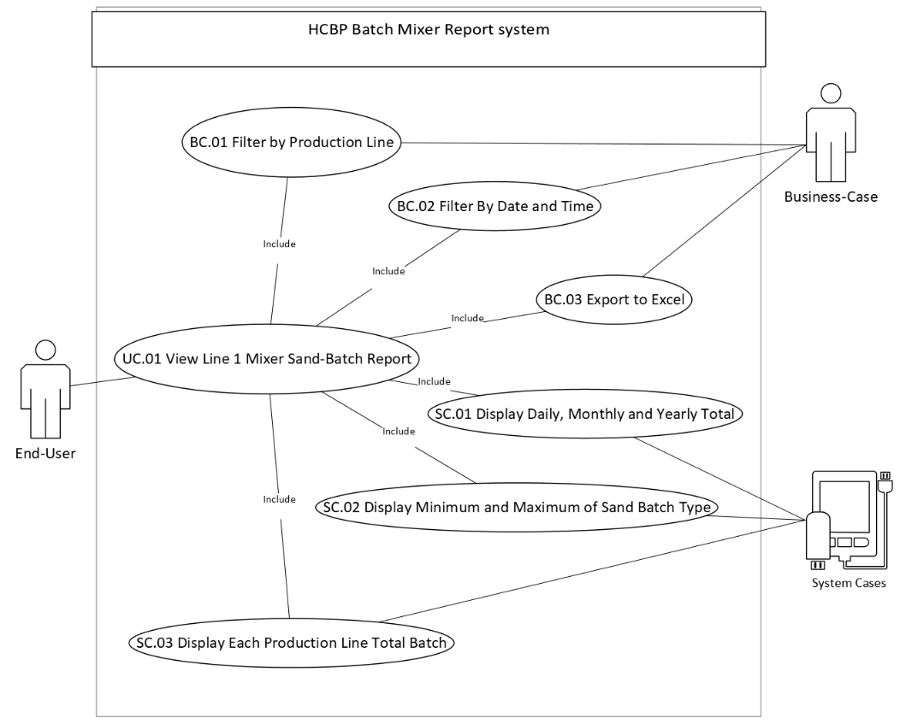
Use Case: short active verb
Use Case ID | UC.01
Use Case Name | View Line 1 Sand Batch Report
Actor(s) | End-User
Description | - End - User Clicks on View Line 1 Mixer Sand -Batch to overview Production Line results
Precondition | - The system is connected to the SQL database.  - The Production Line 1 Mixer Sand Batch results Grid View exists.  - The table contains at least one data record.
Post-condition | - Data is successfully displayed to the user in a readable table
Alternate Flow | - If the table is empty, the system displays a message: "No data found."  - If the table does not exist, a fallback message or exception is triggered.
Exceptions
  - Database connection fails.
  - Table not found.
  - Data retrieval times out.
Main flow of events | Step | User action | System response
 | 1. | End-User Clicks on View Line 1 Mixer Sand Batch Report | System executes SQL query to retrieve latest Mixer Sand Batch results.
 | 2. |  | Information is formatted into a table and displayed on screen.
 | 3. |  | System Display Daily, Monthly and Yearly Total
 | 4. |  | System Display Minimum and Maximum of Mixer Sand Batch Type
 | 5. |  | System Display Each Production Line Total Batch
 | 6. | User Filter by Start Date and End Date Time | System retrieves Filtered Information by Date Time Range
 | 7. | User Export to Excell | System Export data to excel if button clicked

5.2 UC.02
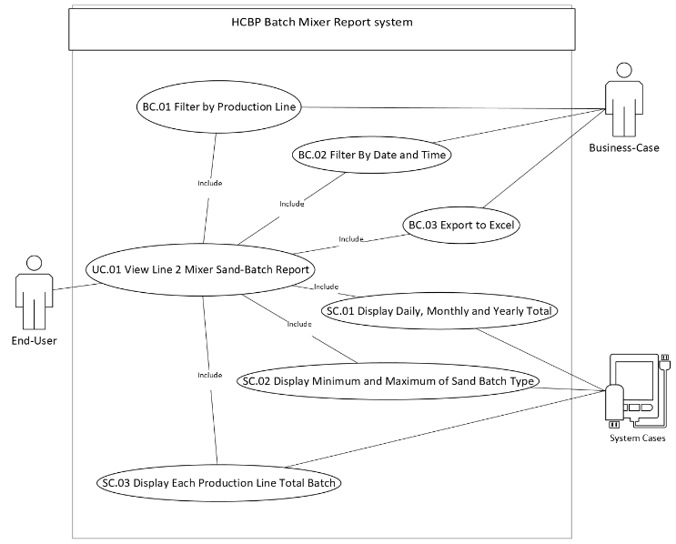
Use Case: short active verb
Use Case ID | UC.02
Use Case Name | View Line 2 Sand Batch Report
Actor(s) | End-User
Description | - End - User Clicks on View Line 2 Mixer Sand -Batch to overview Production Line results
Precondition | - The system is connected to the SQL database.  - The Production Line 2 Mixer Sand Batch results Grid View exists.  - The table contains at least one data record.
Post-condition | - Data is successfully displayed to the user in a readable table
Alternate Flow | - If the table is empty, the system displays a message: "No data found."  - If the table does not exist, a fallback message or exception is triggered.
Exceptions
  - Database connection fails.
  - Table not found.
  - Data retrieval times out.
Main flow of events | Step | User action | System response
 | 1. | End-User Clicks on View Line 2 Mixer Sand Batch Report | System executes SQL query to retrieve latest Mixer Sand Batch results.
 | 2. |  | Information is formatted into a table and displayed on screen.
 | 3. |  | System Display Daily, Monthly and Yearly Total
 | 4. |  | System Display Minimum and Maximum of Mixer Sand Batch Type
 | 5. |  | System Display Each Production Line Total Batch
 | 6. | User Filter by Start Date and End Date Time | System retrieves Filtered Information by Date Time Range
 | 7. | User Export to Excell | System Export data to excel if button clicked

5.3 UC.03
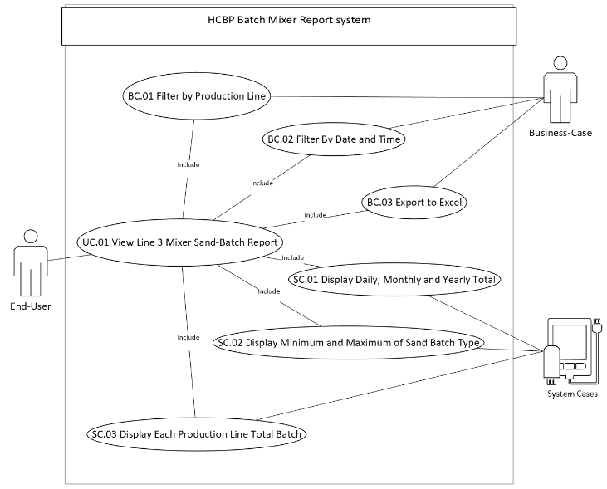
Use Case: short active verb
Use Case ID | UC.03
Use Case Name | View Line 3 Sand Batch Report
Actor(s) | End-User
Description | - End - User Clicks on View Line 3 Mixer Sand -Batch to overview Production Line results
Precondition | - The system is connected to the SQL database.  - The Production Line 3 Mixer Sand Batch results Grid View exists.  - The table contains at least one data record.
Post-condition | - Data is successfully displayed to the user in a readable table
Alternate Flow | - If the table is empty, the system displays a message: "No data found."  - If the table does not exist, a fallback message or exception is triggered.
Exceptions
  - Database connection fails.
  - Table not found.
  - Data retrieval times out.
Main flow of events | Step | User action | System response
 | 1. | End-User Clicks on View Line 3 Mixer Sand Batch Report | System executes SQL query to retrieve latest Mixer Sand Batch results.
 | 2. |  | Information is formatted into a table and displayed on screen.
 | 3. |  | System Display Daily, Monthly and Yearly Total
 | 4. |  | System Display Minimum and Maximum of Mixer Sand Batch Type
 | 5. |  | System Display Each Production Line Total Batch
 | 6. | User Filter by Start Date and End Date Time | System retrieves Filtered Information by Date Time Range
 | 7. | User Export to Excell | System Export data to excel if button clicked

BUSINESS AND SYSTEM FEATURES

6.1 Select by Production Line (Combo Box)

6.1.1 Description and Priority
Description
- This feature enables users to select a Specific Production Line and initiate a system auto search after selection. The system will then display records matching the Selected Production Line.
Priority:
- High. This functionality is essential for users to efficiently locate, and review records associated with a particular Production Line.

6.1.2 Stimulus/Response Sequences
- Stimulus: User Select a Production Line from the Combo Box.
Response: The system retrieves and displays all records that match the Selected Production Line.
- Stimulus: Users select a Production Line and No data Displayed on Table.
Response: The system displays a null Table.

6.1.3 Functional Requirements
- FR1: The system shall provide a Combo Box for users to select a Production Line.
- FR2: The system shall provide a "Search" button adjacent to the Production Line Combo Box.
- FR3: If a Production Line is selected, the system shall query the database for records matching the Selected Production Line.
- FR4: The system shall display the search results in a structured format, such as a table or list.
- FR5: If no matching records are found, the system shall display a message indicating that no results were found.

6.2 Select by Date and Time

6.2.1 Description and Priority
Description
- This feature enables users to select a specific Date and Time into a Select Box and initiate a search. The system will then display records matching the selected Date and Time.
Priority:
- High. This functionality is essential for users to efficiently locate, and review records associated with a particular Date and Time.

6.2.2 Stimulus/Response Sequences
- Stimulus: User Select Date and Time into the Select Box and Execute Search.
Response: The system retrieves and displays all records that match the Selected Date and Time.
- Stimulus: Users select Date and Time that does not exist in the database and clicks "Search".
Response: The system displays a null Table.

6.2.3 Functional Requirements
- FR1: The system shall provide a select box for users to input a Date and Time.
- FR2: If Date and Time is selected, the system shall query the database for records matching the selected Date and Time.
- FR3: The system shall display the search results in a structured format, such as a table or list.
- FR4: If no matching records are found, the system shall display a message indicating that no results were found.

6.3 Export to Excel

6.3.1 Description and Priority
Description:
This feature allows users to export the displayed data from the Grid View:
- Excel: Enables users to export the data as an Excel (.xlsx) file. Upon initiating either action, the system will prompt the user to specify a file name and choose a save location.
Priority:
- High. This functionality is crucial for users to efficiently analyse and compare information, as well as maintain accurate records.

6.3.2 Stimulus/Response Sequences
- Stimulus: User clicks the "Export to Excel" button.
Response: The system generates an Excel (.xlsx) file containing the current Grid View data and prompts the user to save the file.
- Stimulus: User attempts to export when the Grid View is empty (i.e., contains no data).
Response: The system displays a message indicating that there is no data available for export.

6.3.3 Functional Requirements
- FR1: The system shall provide an "Export to Excel" button accessible to the user.
- FR2: Upon clicking the "Export to Excel" button, the system shall generate an Excel (.xlsx) file containing the current data displayed in the Grid View.
- FR3: The system shall prompt the user to specify a file name and select a save location when exporting to Excel.
- FR4: If the Grid View contains no data, the system shall prevent the export action and display a message indicating that there is no data to export.
- FR5: The exported files shall retain the formatting and structure of the Grid View, including headers and data alignment.

Display Daily, Monthly and Yearly Total

6.4.1 Description and Priority
Description:
This feature allows users to view the Daily, Monthly, or Yearly Total of Mixer Sand Batch Report per production Line.
- The system shall then display the total quantities for the selected period (daily total for a day, aggregated monthly total for a month, or aggregated yearly total for a year).
Priority:
- High – Users rely on this functionality to quickly locate and analyse aggregated totals for specific time frames.

6.4.2 Stimulus / Response Sequences
- Stimulus: User selects a particular day (with date and time) and clicks Search.
Response: The system retrieves and displays the daily total for that specific date.
- Stimulus: User selects a specific month (e.g., “May 2025”) and clicks Search.
Response: The system retrieves and displays the total aggregated quantity for that month.
- Stimulus: User selects a specific year (e.g., “2024”) and clicks Search.
Response: The system retrieves and displays the total aggregated quantity for that year.
- Stimulus: User selects a period (day/month/year) with no matching records and executes the search.
Response: The system displays an empty table or a “No results found” message.

6.4.3 Functional Requirements
- FR1: The system shall provide a select-box allowing users to choose a day, month, or year.
- FR2: When a period is selected and Search is executed, the system shall query the database for records matching the chosen date range.
- FR3: If matching records are found, the system shall display the aggregated total quantity for the selected period in a structured format (e.g., table or list).
- FR4: If no matching records are found, the system shall display an empty table or a clear message “No results found.”

Display Minimum and Maximum of Mixer Sand Batch Type

6.5.1 Description and Priority
Description:
This feature allows users to view the Minimum and Maximum of Mixer Sand Batch Type per production Line.
- The system shall then display the Minimum and Maximum of Mixer Sand Batch Type per production Line.
Priority:
- High – Users rely on this functionality to quickly locate and analyse Minimum and maximum of Mixer Sand Batch Type.

6.5.2 Stimulus / Response Sequences
- Stimulus: User selects a particular day (with date and time) and clicks Search.
Response: The system retrieves and displays the daily total for that specific date.
- Stimulus: User selects a specific month (e.g., “May 2025”) and clicks Search.
Response: The system retrieves and displays the total aggregated quantity for that month.
- Stimulus: User selects a specific year (e.g., “2024”) and clicks Search.
Response: The system retrieves and displays the total aggregated quantity for that year.
- Stimulus: User selects a period (day/month/year) with no matching records and executes the search.
Response: The system displays an empty table or a “No results found” message.

6.5.3 Functional Requirements
- FR1: The system shall provide a select-box allowing users to choose a day, month, or year.
- FR2: When a period is selected and Search is executed, the system shall query the database for records matching the chosen date range.
- FR3: If matching records are found, the system shall display the aggregated total quantity for the selected period in a structured format (e.g., table or list).
- FR4: If no matching records are found, the system shall display an empty table or a clear message “No results found.”

USER ACTIVITY DIAGRAM

7.1 User Activity Diagram Figure
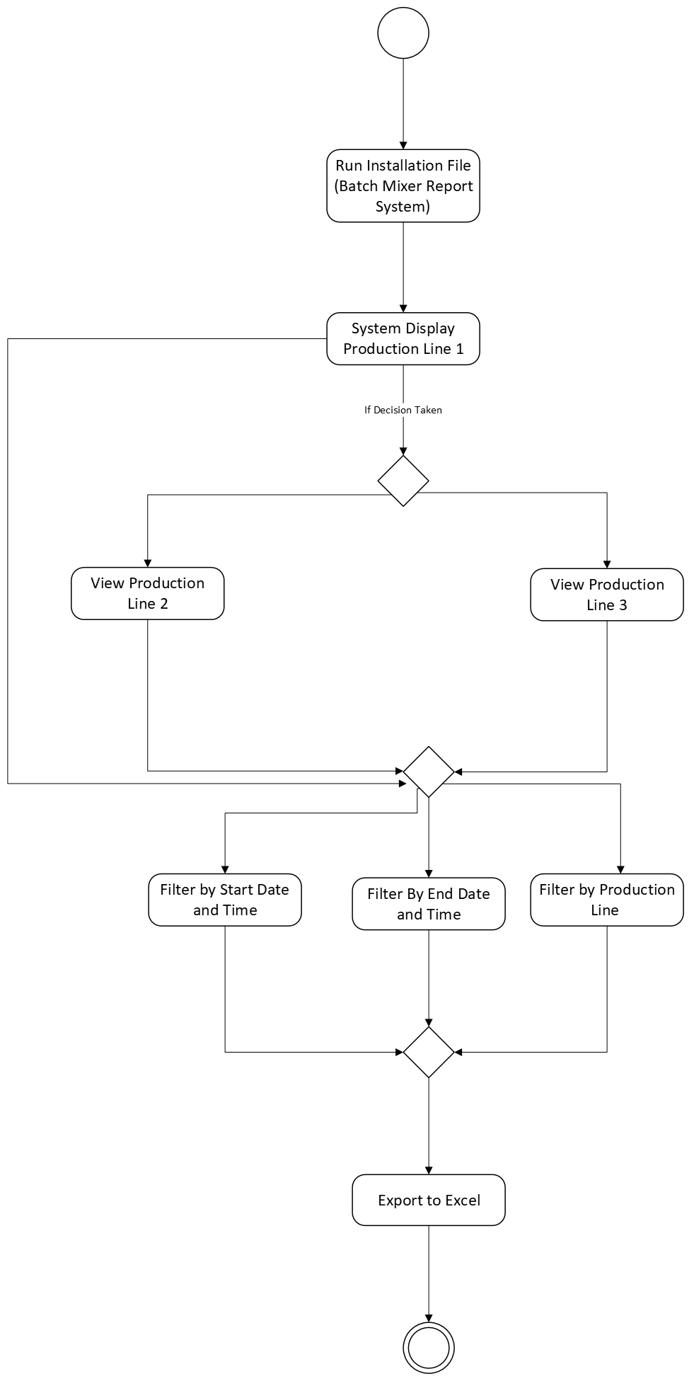

USER ACTIVITY DIAGRAM AND USER BREAKDOWN STORIES

8.1 UAD Production Line 1
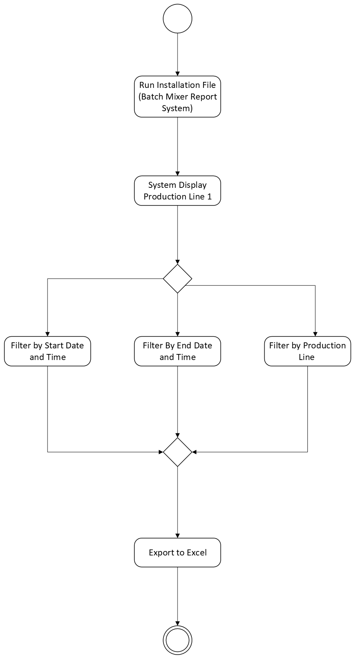

8.1 Operator View Production Line 1 Report
|
IF (Data! = Null)
8.1.1 Display Production Line 1 Report
8.1.2 Filter Batch Mixer Report Information
8.1.2.1 Filter by Date
8.1.2.2 Filter by Time
8.1.2.3 Filter by Production Line
8.1.3 Export to Excell
8.1.3.1 Export Table Data to Excel
|
ELSE
{“Console No Production Line 1 Report Information Available for Display”}

8.2 UAD Production Line 2
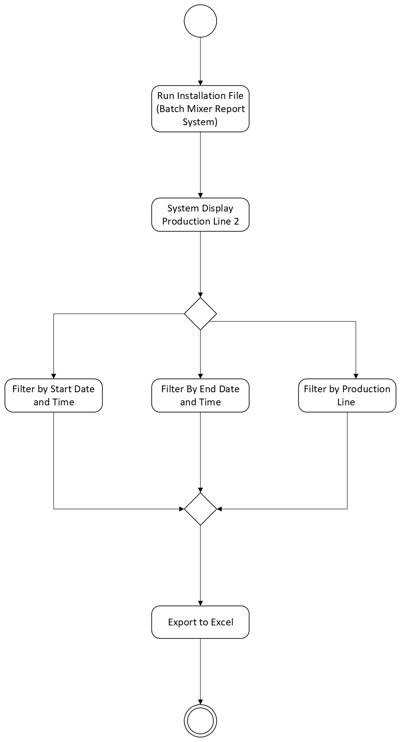

8.2 Operator View Production Line 2 Report
|
IF (Data! = Null)
8.2.1 Display Production Line 2 Report
8.2.2 Filter Batch Mixer Report Information
8.2.2.1 Filter by Date
8.2.2.2 Filter by Time
8.2.2.3 Filter by Production Line
8.2.3 Export to Excell
8.2.3.1 Export Table Data to Excel
|
ELSE
{“Console No Production Line 2 Report Information Available for Display”}

8.3 UAD Production Line 3
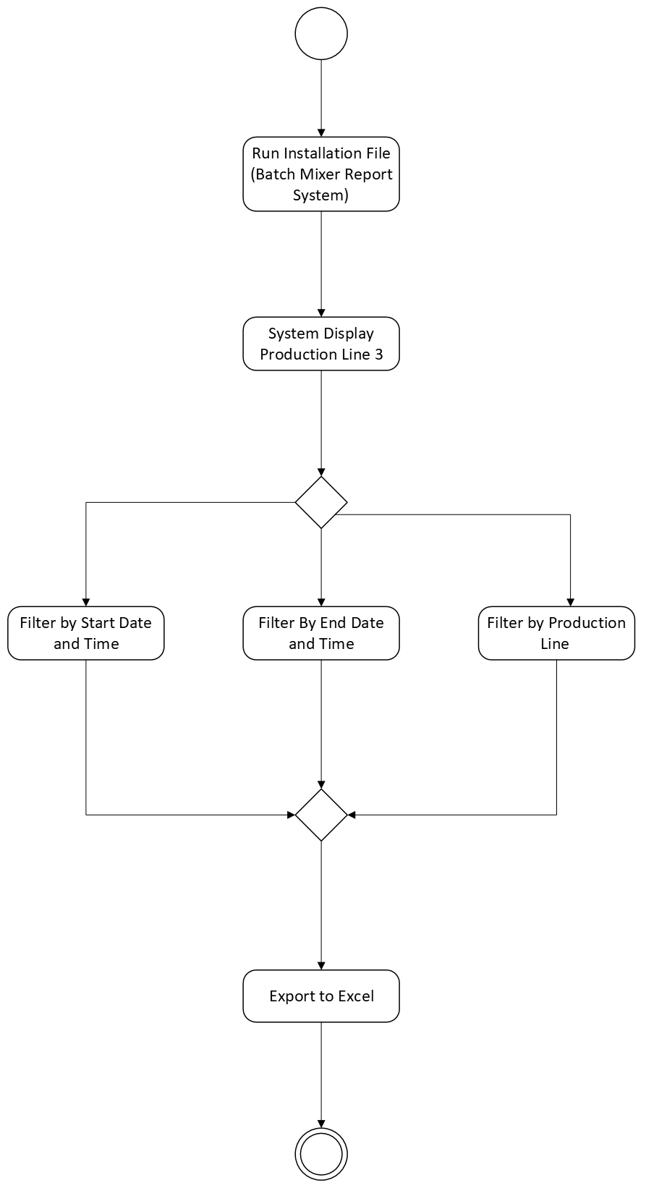

8.3 Operator View Production Line 3 Report
|
IF (Data! = Null)
8.3.1 Display Production Line 3 Report
8.3.2 Filter Batch Mixer Report Information
8.3.2.1 Filter by Date
8.3.2.2 Filter by Time
8.3.2.3 Filter by Production Line
8.3.3 Export to Excell
8.3.3.1 Export Table Data to Excel
|
ELSE
{“Console No Production Line 3 Report Information Available for Display”}

CONCLUSION
The Batch Mixer Report System – Alpha Version will mark a significant milestone in the High Chrome Ball Plant’s journey toward digital transformation. By automating sand batch data collection, analysis, and reporting, this system will establish a standardized, traceable, and efficient workflow that directly supports quality control, metallurgical validation, and rapid decision-making.
This SRS has clearly defined the system’s scope, objectives, interfaces, and detailed functional requirements—providing a comprehensive blueprint for developers, metallurgists, operators, and QA personnel. As discussed in Requirements Gathering Document, a well-prepared SRS aligns business and technical goals, facilitates clear stakeholder communication, and serves as the foundation for scheduling, risk, and compliance checks.

